**Spatial patterns in near bottom oceanographic variables collected during AFSC bottom trawl surveys.**

Principal Investigators - Chris Rooper (AFSC – RACE), Pam Goddard (AFSC-RACE), Jerry Hoff (AFSC – RACE)

Contact: Chris.Rooper@noaa.gov

**Last updated: October 2016**

**Description of index**: In 2012 the RACE Division purchased four SeaGuard CTD units (funded by the North Pacific Research Board and Deep Sea Coral Research and Technology Program). These units were purchased to increase the oceanographic data collections during bottom trawl surveys of the eastern Bering Sea slope, Gulf of Alaska and Aleutian Islands.

The CTD units collect concurrent depth, temperature, salinity, pH, oxygen and turbidity data. The units are deployed on the headrope of the AFSC bottom trawls during most survey hauls. To date, the data has been collected on the 2012 and 2016 EBS slope, the 2013 and 2015 GOA and the 2014 and 2016 Aleutian Islands bottom trawl surveys.

The data is presented here as a series of maps of bottom variables (the average value of each variable during the on-bottom period of the bottom trawl haul). The data have been interpolated to a 1 km by 1 km raster using R software. For salinity, pH and oxygen kriging with a fitted exponential semi-variance model was used based on the spatial pattern in semi-variance plots. The turbidity data exhibited a linear decrease in semi-variance with distance, so inverse distance weighting was used for this variable. The EBS slope data collection in 2012 (n = 188 trawl hauls) and 2016 (n = 157 trawl hauls) covered the entire continental slope at depths from ~200 m to 1200 m (Figure 1). The data were not corrected for time of the year, so some within-season temporal effects could be present because of the prosecution of the EBS slope survey from south to north in the first half of the survey and then a return south in the second half of the survey.

**Status and trends**: 2016 was a much warmer year than 2012 throughout the slope. In 2012, the warmest water was in the south and temperatures decreased as you moved north, however, in 2016 there were pockets of warm water throughout the slope area with no south-north trend (Figure 2)

Salinity was generally highest in 2016 and was fairly uniform over the slope, although water tended to become slightly less salty at shallower depths. In 2012, salinity over the slope was generally less. Salinity varied between 32.8 and 34.3 ppm in 2012 and 33.2 and 34.6 in 2016.

Oxygen concentrations were lower in 2016 than in 2012. The spatial patterns in Oxygen were similar between the two years, with higher Oxygen concentrations in Bering Canyon and in some of the canyons to the north (particularly the southern arm of Pribilof Canyon), but Oxygen was uniformly lower in 2016.

pH was distinctly different between the two years. The pH was measured from 7.5 to 7.9 in 2012, while it was only 7.1 to 7.2 in 2016. This is a suspiciously large change over the two years and may point to some issues with the equipment. The pH meters have been untrustworthy with at least 3 failures in the last 2 years. A better measurement system for pH is needed.

Turbidity was constant and low in both 2012 and 2016, with the exception of a station between Zhemchug and Pervenets canyons, which had elevated turbidity (> 115).

**Factors causing observed trends**: The observed spatial trends in near bottom temperature and salinity are likely caused by relationships to depth in the EBS. The trends in other variables are likely the result of areas of differential primary production and other oceanographic features. The observed spatial patterns in oxygen in the eastern Bering Sea slope is probably a result of the interaction between depth and currents moving up through the canyons along the slope.

**Implications**: As more of this data is collected relationships between fish and invertebrate distributions will be explored. When more years of data have been collected for each area, variability of spatial patterns may be important.

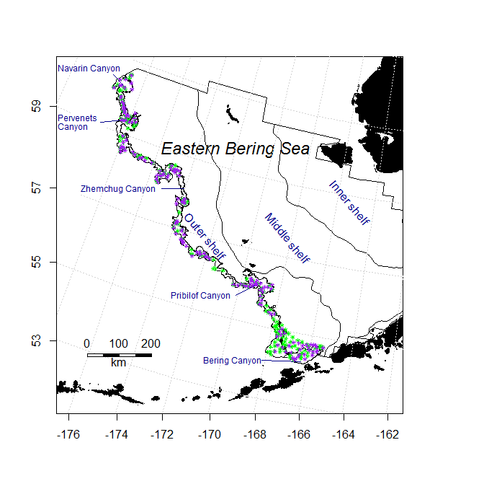

Figure 1. Locations for 2012 (green, n = 188) and 2016 (purple, n = 157) CTD deployments on the headrope of the bottom trawl used in the eastern Bering Sea slope bottom trawl survey.

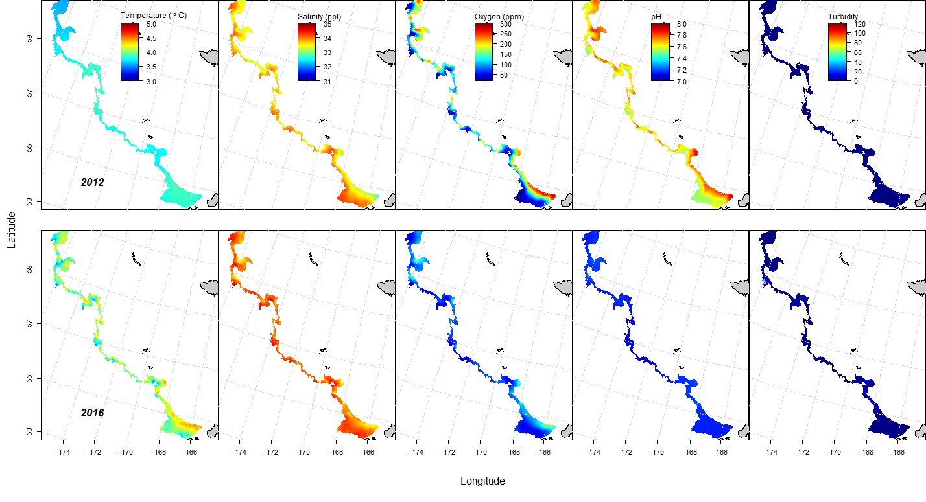

Figure 2. Maps of interpolated temperature, salinity, oxygen concentration, pH, and turbidity for the eastern Bering Sea slope in 2012 and 2016. The data were collected at bottom trawl survey stations, averaged for the on-bottom portion of the bottom trawl haul and were interpolated to a 1 km by 1 km grid for the slope.